SPC FLOOORING
SPC floor is the 2nd generation of vinyl flooring which was produced by extrusion moulding.
SPC
SPC FLOOR STRUCTURE  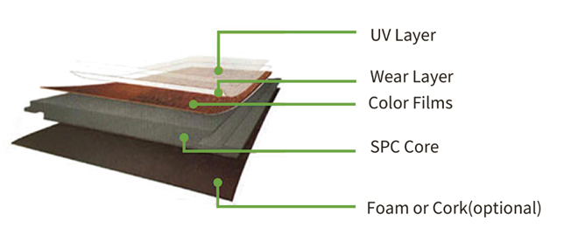 | 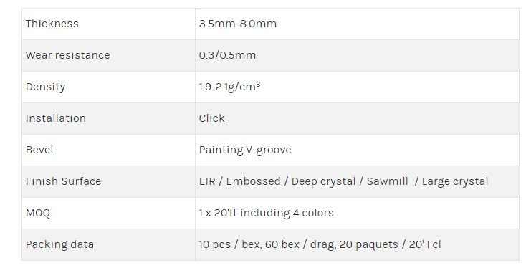

TECHNICAL DATA
Density |  | 1.9-2.1g/cm³
Dimensional stability | ISO 23999:2008 | X Direction: 0.08%  Y Direction: 0.07%
Curling | ISO 23999:2008 | ≤1.0mm
Residual indentation | ISO 24343-1:2007 | -0.04mm
Light stability | IS0105-B02:Method 3 | ≥6
Castor chair | ISO4918 | After 25000 cycles,test specimens no visible damage
Classification | EN ISO 10S82 | 23,31/33,42
Reaction to fire | EN 13501-1 | Bfl-S1
Slip resistance | DIN 51130:2010 EN 13893 | R10 DS
Wear resistance | EN 660-2 | 500 grams of pressure The amount of wear ≦0.015g
Thermal resistance | EN 12667:2001 | 0.038m²K/W
Determination of resistance to stains chemical resistance | ISO26987:2008 | Resistant
Squareness | ISO24342:2007 | Deviation range: X Direction: 0.00mm~+0.05mm  Y Direction: 0.00mm~+0.05mm
Straightness | ISO24342:2007 | Deviation range: X Direction: 0.00mm~+0.03mm  Y Direction: 0.00mm~+0.05mm
Peel resistance | ISO 24345:2006 | X Direction: 6SN/50mm  Y Direction: 65N/50mm
Determination of resistance to stubbed and burning cigarettes | EN1399:1997 Method 8 | Rating 3: Moderate change  of gloss and moderate brown stain

